FRIENDS AND FAMILY TEST
Results for June 2023
Thank you to all the patients who completed a friends and family test survey in.

- How likely are you to recommend our practice to family and friends if they needed similar care or treatment?
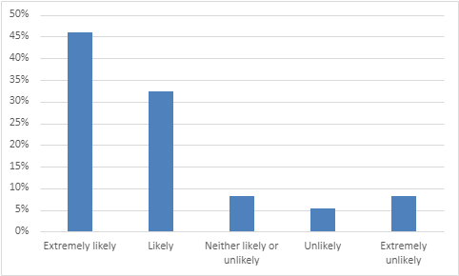
46% extremely likely to recommend the practice
32% are likely to recommend the practice
8% are neither likely nor unlikely to recommend the practice
5% are unlikely to recommend the practice
8% are extremely unlikely to recommend the practice

- If we could change one thing about your care or treatment, what would it be?
- Nothing, the care and treatment I receive is always excellent.
- Excellently run surgery, nothing negative to say.
- Really pleased with the proactive ethos of the doctors and practice nurse.
- The members of the admin staff are always polite and very helpful. Nice friendly receptionist.
- Everyone is very respectful and I appreciate the work you do. Always someone to help you.
- Reduce waiting times for appointments.
- Offer more face to face appointments.
- Be able to see a doctor when I want.
- Have questions answered more effectively.
- Provide better mental health care.
- Have telephone calls returned quickly.
- To be listened to.
- It is sometimes difficult to get through on the telephone.
- When you ring to make an appointment with the doctor, it should be a doctor who sees you and not a nurse.

